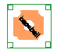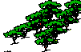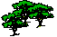
HILL
start
1mileMI
2mileMI
Concessions
bathrooms

Neenah High School
Stay off paved path!
bubbler
bathroom
bathroom
bubbler
Track
1st Loop
2nd Loop

